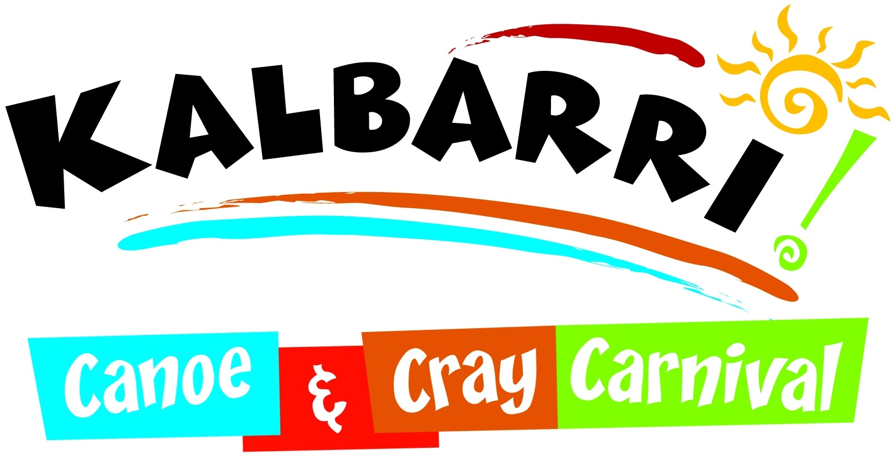

Registration & Rules
The challenge is a low & slow, smoked meat cooking contest for the smoking enthusiast
who wants to prove they have what it takes to be the best in our local Kalbarri competition.
The event will consist of teams of one to four cooks, cooking any cut of Beef, Pork, Lamb or Fish. Each team will be allocated an area at the Kalbarri Canoe and Cray Carnival which will consist of a marquee. You will need to supply all equipment, utensils, food/meat & clean up for the one-day event.

NO open fires or electricity allowed. Enclosed fires & gas equipment only.

Areas, equipment & meat will be inspected at 7am Saturday 1st June.

Your perfectly smoked meat will be judged by a group of carefully selected locals & sponsors. Who will be judging the Texture, Taste, Appearance & Skills of your meat & the skills you or your team have shown.

Judging takes place from 5:30pm with the WINNERS being announced at the main stage at 6pm. Before cooking commences you will fill in a form listing ingredients of marinades, garnishes, cut of meat & the style of smoking you will be using.

You can start cooking from 7:15am

Cooking can only be done in allocated area though if your marinating this can take place at home during the lead up.

Kalbarri Canoe and Cray Carnival take no responsibility for any injury or loss suffered by participants during the event.

Please return completed form to Milly
via email millywhite4@gmail.com or phone 0408 075 759 for collection.
You will receive a confirmation email including the Official Rules & times.

Free Entry & Registrations Close by 20th May 2019

Get your teams ready & let’s find out who is the Best!!

PROUDLY SPONSORED BY
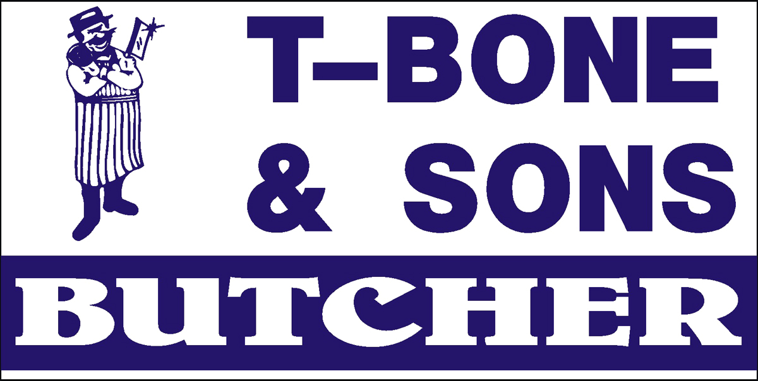

Team Name:

Team Members:
- _________________________________
- _________________________________
- _________________________________
- _________________________________

Contact Person:

Email:________________________________

Phone:________________________________

Please return to Milly White by
emailing to millywhite4@gmail.com or call 0408 075 759

Free Entry & Registrations Close by 20th May 2019

www.kalbarricanoeandcray.com
www.facebook.com/kalbarricanoeandcraycarnival

PROUDLY SPONSORED BY

